ARI2129 – Data Annotation Journal

Note: There was no use of Generative AI throughout the writing process.

News Video Segmentation

I annotated the news video with ID 3, using the following email address to login: [matthias-vassallo.pulis@um.edu.mt](mailto:matthias-vassallo.pulis@um.edu.mt). The video covered the news headlines from the 20th of January 2024.

The segmentation process was smooth, as everything which had to be classified was clearly identified. I focused on the following 5 features: Studio, Story, Illustration, Advertisement, and Transition. There was a high number of Studio and Story segments in the video, while the rest were featured the least.

There were not any challenges present during the video annotation process. However, I did not expect that I would encounter a higher number of illustrations throughout the video. This was because before starting to annotate the video, I only expected to encounter 1 or 2 of these, yet I observed exactly 5 illustrations throughout the whole process.

News Website Eye-Tracking

This eye-tracking process made me more self-aware about which parts of a news website I look at the most and which parts I look at the least. This experience did not alter how I usually interact with news sites in any way. However, throughout the process, it almost felt like I was straining my eyes given that I had to only move my eyes to not mess up the data sent to the system.

Tombstone Annotation

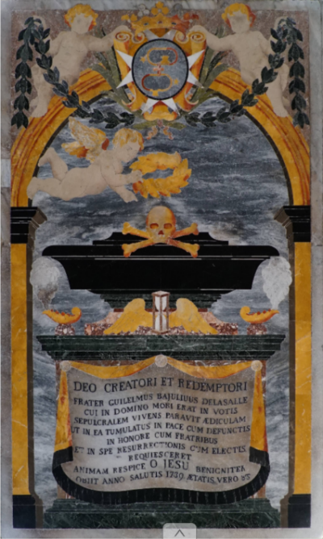

Figure 1 - Screenshot of original image used for annotation – ID: 83

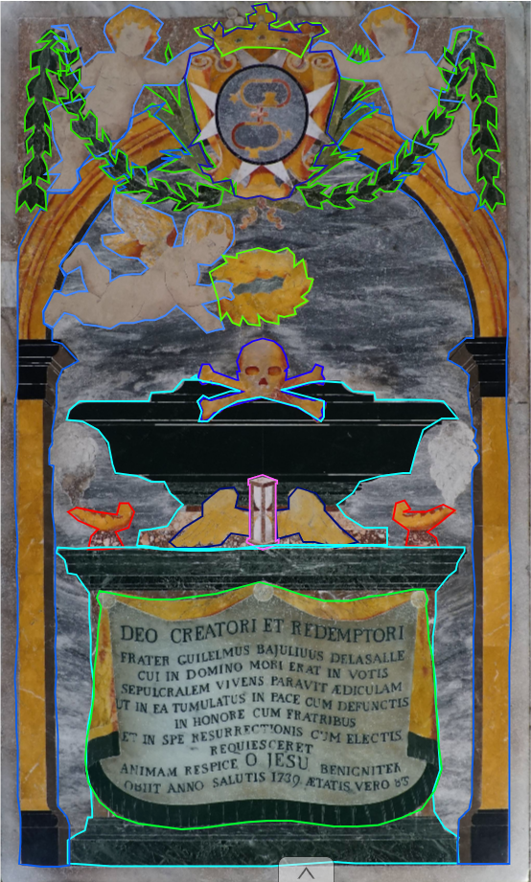

Figure 2 - Screenshot of annotated image - ID: 83

I annotated the following parts from the image: Arch, Skull, Laurel wreath, Candle, Angel, Wings, Escutcheon, Crown, Cartouche, Sarcophagus, and sandglass. There were difficulties when annotating the image, as some of the annotated shapes do not fit perfectly with the border of each object, especially at corners or rounded parts.

This project made me learn more about different objects that exist in a painting of this calibre. It helped me appreciate the artwork of St John’s Co-Cathedral even more.